Template for Preparation of Extended Abstract for SSNR2024
First A. Author, Second B. Author, and Third C. Author
Abstract—This is an example of how to prepare the two-page Extended Abstract for the 2024 Summer School on Neurorehabilitation (SSNR2024), which will be held in Baiona (Spain) from June 16 to 21, 2024. The abstract (meaning this part of your Extended Abstract) should be no more than 150 words. The abstract should give a clear indication of the objectives, scope, and results of the paper. Do not delete the blank line immediately above the abstract; it sets the footnote at the bottom of this column.

INTRODUCTION
T
HIS document is a template for Microsoft Word versions 6.0 or later based on IEEE manuscript specifications for a conference proceedings article. For your convenience we have prepared also a LaTeX version of it. You can download both templates from the Paper Submission Section of the website: www.summerschoolneurorehabiliation.org. You can choose whatever version you prefer.
All contributions will be peer reviewed. Accepted contributions will appear in Conference Proceedings. The Proceedings will be published as a pdf file.

The contribution should contain the following sections: Introduction, Material and Methods, Results, Discussion, Conclusions, and References.

Formatting Instructions

Text
Highlight a section that you want to designate with a certain style, then select the appropriate name on the style menu. The style will adjust your fonts and line spacing. Do not change the font sizes or line spacing to squeeze more text into a limited number of pages. Use italics for emphasis; do not underline.

Figures
Photographs, grayscale and color figures should be prepared with at least 300 dpi resolution, 8 bits per pixel (palette or 256 color).
To insert images in Word, position the cursor at the insertion point and either use Insert | Picture | From File or copy the image to the Windows clipboard and then Edit | Paste Special | Picture (with “Float over text” unchecked).
For the tables, use horizontal lines but no vertical lines. Hide gridlines (Table | Hide Gridlines). Use text style according to Table. I. Do not abbreviate “Table.” Tables are numbered with Roman numerals.
Large figures and tables may span both columns. Place figure captions below the figures; place table titles above the tables. If your figure has two parts, include the labels “(a)” and “(b)” as part of the artwork. Please do not include captions as part of the figures. Do not put captions in “text boxes” linked to the figures. Do not put borders around the outside of your figures. Use the abbreviation “Fig.” even at the beginning of a sentence. Separate the figure from the text above the figure with one space (as shown in Fig. 1).

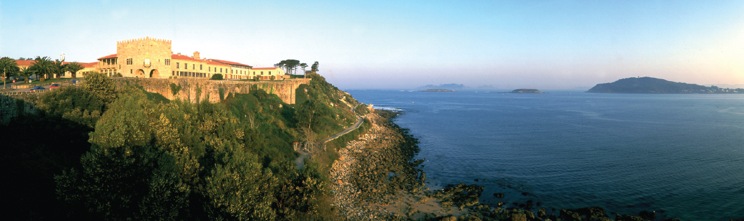
Fig. 1. The city of Baiona, where SSNR2023 will take place. Note that “Fig.” is abbreviated. There is a period after the figure number, followed by two spaces. Set a spacing of 6pt. before the caption. Indent the caption 0.3 cm on both sides.

Math and equations
Number equations consecutively with equation numbers in parentheses flush with the right margin, as in (1). First use the equation editor to create the equation. If you are using Word, use either the Microsoft Equation Editor or the MathType add-on (http://www.mathtype.com). “Float over text” should not be selected. Press the tab key and write the equation number in parentheses. To make your equations more compact, you may use the solidus ( / ), the exp function, or appropriate exponents. Use parentheses to avoid ambiguities in denominators.

(1)

Be sure that the symbols in your equation have been defined before the equation appears or immediately following. Italicize symbols (T might refer to temperature, but T is the unit tesla). Refer to “(1),” not “Eq. (1)” or “equation (1)”.

Units
Use SI (MKS) as primary units. English units may be used as secondary units (in parentheses).Avoid combining SI and CGS units.

References
Number citations consecutively in square brackets [1]. The sentence punctuation follows the brackets [2]. Multiple references [2], [3] are each numbered with separate brackets [1]–[3]. In sentences, refer simply to the reference number, as in [3]. Do not use “Ref. [3]” or “reference [3]”. Type the reference list at the end of the paper using the “References” style (see the references at the end of this document). Give all authors’ names; do not use “et al.” unless there are six authors or more. Use a space after authors' initials. Papers that have not been published should be cited as “unpublished” [4]. Papers that have been submitted for publication should be cited as “submitted for publication” [5]. Papers that have been accepted for publication, but not yet specified for an issue should be cited as “to be published” [6]. Please give affiliations and addresses for private communications [7].
Number footnotes separately in superscripts (Insert | Footnote). Place the actual footnote at the bottom of the column in which it is cited.

Writing recommendations
Use one space after periods and colons. If you wish, you may write in the first person singular or plural and use the active voice (“I observed that ...” or “We observed that ...” instead of “It was observed that ...”). Remember to check spelling. If your native language is not English, please get a native English-speaking colleague to proofread your paper.
An excellent style manual and source of information for science writers is [9]. A general IEEE style guide, Information for Authors, is available at www.ieee.org/organizations/pubs/transactions/information.htm.
TABLE I
Conference Calendar
Day | Activity
June 12, 2023 | SCI day
June 13, 2023 | Rehabilitation Robotics day
June 14, 2023 | Prosthetics day
June 15, 2023 | Robotics & Students’ day
June 16, 2023 | Interfacing & Students’ day

Editorial Policy
Submission of a manuscript is not required for participation in a conference. Do not submit a reworked version of a paper you have submitted or published elsewhere. The submitting author is responsible for obtaining agreement of all coauthors and any consent required from sponsors before submitting a paper. It is the obligation of the authors to cite relevant prior work.
The decision to accept or reject a paper is made by the conference editors and publications committee; Undecipherable English is a valid reason for rejection.

Conclusion
A brief conclusion section is welcome. A conclusion may review the main points of the paper. Do not replicate the abstract as the conclusion. A conclusion might elaborate on the importance of the work or suggest applications and extensions.

Acknowledgment
Sponsor and financial support acknowledgments are placed in the unnumbered footnote on the first page.

References
- G. O. Young, “Synthetic structure of industrial plastics (Book style with paper title and editor),” in Plastics, 2nd ed. vol. 3, J. Peters, Ed. New York: McGraw-Hill, 1964, pp. 15–64.
- W.-K. Chen, Linear Networks and Systems (Book style). Belmont, CA: Wadsworth, 1993, pp. 123–135.
- H. Poor, An Introduction to Signal Detection and Estimation. New York: Springer-Verlag, 1985, ch. 4.
- B. Smith, “An approach to graphs of linear forms (Unpublished work style),” unpublished.
- E. H. Miller, “A note on reflector arrays (Periodical style—Accepted for publication),” IEEE Trans. Antennas Propagat., to be published.
- J. Wang, “Fundamentals of erbium-doped fiber amplifiers arrays (Periodical style—Submitted for publication),” IEEE J. Quantum Electron., submitted for publication.
- C. J. Kaufman, Rocky Mountain Research Lab., Boulder, CO, private communication, May 1995.
- Y. Yorozu, M. Hirano, K. Oka, and Y. Tagawa, “Electron spectroscopy studies on magneto-optical media and plastic substrate interfaces(Translation Journals style),” IEEE Transl. J. Magn.Jpn., vol. 2, Aug. 1987, pp. 740–741 [Dig. 9thAnnu. Conf. Magnetics Japan, 1982, p. 301].
- M. Young, The Techincal Writers Handbook. Mill Valley, CA: University Science, 1989.

Sponsor and financial support acknowledgment goes here. Paper titles should be written in uppercase and lowercase letters, not all uppercase. Full names of authors are preferred in the author field, but are not required. Put a space between authors' initials. F. A. Author is with the Bioengineering Group of the Spanish National Research Council, Madrid, Spain (corresponding author to provide e-mail: author@csic.es). S. B. Author, is with theBiomechanics and Technical Aids Department National Hospital for Spinal Cord Injury, Toledo, Spain (e-mail is preferable). T. C. Author is with Fondazione Santa Lucia, Rome, Italy (e-mail is preferable).
It is recommended that footnotes be avoided (except for the unnumbered footnote with the receipt date on the first page). Instead, try to integrate the footnote information into the text.

